Universal Guidelines
- Nested headings must use decreasing order size (Heading 2, Heading 3, Heading 4, etc.). Do not skip a heading size.
- Formatting
  - Division Heading—Ariel 18, bold
  - Headings in Faculty Listing—Ariel 11, bold
  - Heading 1—Times New Roman 16, bold
  - Heading 2—Times New Roman 12, bold
  - Heading 3—Times New Roman 12, italics, bold
  - Heading 4—Times New Roman 12, italics

Department Pages (Graduate Catalog)

Overview
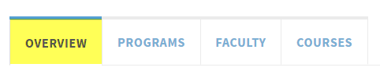

The following two items must be listed:

An “Introduction” that provides an overiew of the academic department.
- “Admission” information for the program(s) offered. You may have a separate “Admission” section for each program if needed.
Other items that may be listed here:
- Financial Aid
- Facilities
- Scholarships/Fellowships/Assistantships
- Research
Example: http://catalog.unc.edu/graduate/schools-departments/history/

Programs
- Each degree offered listed separately.
- Requirements of the degree. (not required but strongly recommended)
- Additional information about the degrees, concentrations, specializations, etc.

Faculty
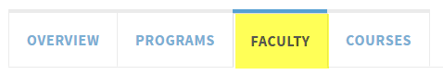
- Faculty should be listed as follows:
  - FirstName LastName (in bold), research/teaching area
- Faculty should be listed by rank, with rank as Header 1
- Recommended order for ranks:
- Professors
- Associate Professors
- Assistant Professors
- Emeriti.
- Example: http://catalog.unc.edu/graduate/schools-departments/biostatistics/#facultytext

Courses (maintained by the Registrar’s Office)
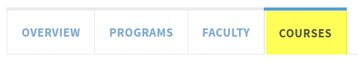
Important: The content on this tab is populated by data from ConnectCarolina; please do not edit this tab.
Contact Box  This appears on the top right of the Overview tab.  Included Information:  - Department name  - Department URL  - Department Physical Address and Campus Box  - Department Phone | 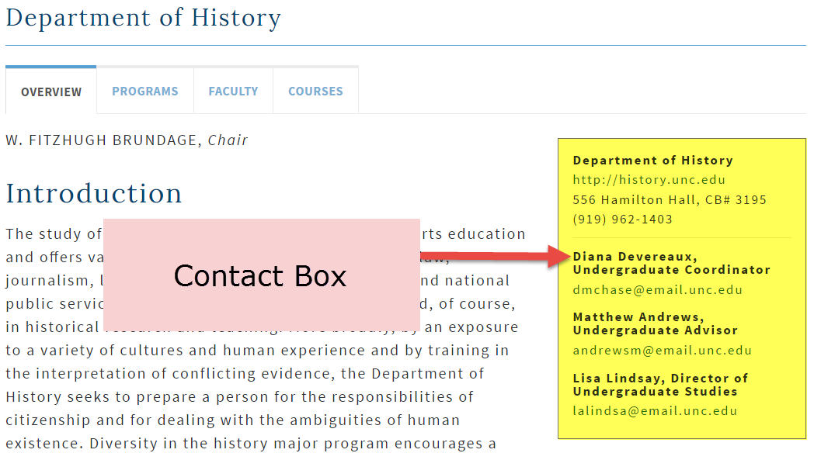
- Contact Names may include the following roles:
- Chair
- Director of Graduate Studies
- Student Services Manager
- Other department roles as appropriate

Note: There is a special tool that enables users to enter contact information on any page in the catalog. This feature is most often used in the departments. In addition, this contact information can be inherited to children pages if the child page is a program page (identified by the program check box in Setup). Child pages will inherit the parent's department information and people, unless they have their own specific people. If they have their own people, those people will be displayed along with the department information.

Formatting
In general, please follow the style that you see in the catalog, which is based on the Chicago Manual of Style. We have made some additional style decisions in order to maintain consistency. The following are a few noted issues. Please feel free to ask if you are not sure. Strange and unique situations can come up.

- Acronyms/Abbreviation
  - Use acronym in parenthesis the first time the entire title is spelled out. Place them after the entire title. Then use the acronym consistently. Do not change back and forth. If you spell out a title a lot, make sure to spell it out all the time.
  - We recommend abbreviating grade point average to GPA as much as possible, as it is a well-known abbreviation.

- Advisor vs adviser – for the catalog
  - For the catalog, advisor should be used when describing the title or job of a person. That is how it is spelled in PeopleSoft when referring to program/student advisors.
  - Advisor will come up as not spelled correctly in the editor, but it is a correct spelling.

- Capitalization:
  - Only capitalize FULL titles, proper names, nationalities, and names of languages. (i.e. Department of Biology; Office of Student Life; Director of the School of Education; English; Spanish; Accountancy Program; Master of Science in Biology Program)
  - Do not capitalize partials or non-titles (i.e. art department; art; teacher certification program; dean; department chair)
  - Do not capitalize subjects or majors. (i.e. accounting, international business major, computer science minor)
  - Do not capitalize “general education” unless it is the whole title “General Education Program.”
  - Approaches, Connections, Foundations, but behavioral science, quantitative reasoning
  - Do not capitalize “degree.”
  - Capitalize “University” in all instances except when using it generically. (I.e., the University, University-wide. But: UNC-Chapel Hill is a top-ten university.)
  - Do not capitalize “dean,” “chair,” “college,” “office,” or “committee” when used by themselves.
  - Capitalize: “Dean’s List.” It is the official title of an honor and should be capitalized.
  - Do not capitalize bachelor of arts, bachelor of science, master of science when these degrees are mentioned in running prose. But capitalize them if they are list items.
  - Hyphenated words in titles are capitalized: Two-Dimensional Imaging, Free-Fall (not Free-fall).
  - Lowercase all prepositions in titles (Chicago), including through, since, across (Language across the Curriculum).
  - Lowercase subject matters/disciplines unless conventionally capitalized or part of an official title: “The Department of Biology graduates many biology majors.” but “Majors in French often study abroad.”
  - Use “See DEPT XXX for description.” for all courses appearing in nonsponsoring unit.

- Courses or inline courses
  - Include the subject prefix for every reference (it can’t be linked without it). Example: ARTH 204, ARTH 223, and ARTH 323. Do not do ARTH 204, 223, and 323.
  - To change the format of the course title after linking, double click on the blue box and choose a format option in the bottom Format drop down menu. So far we have only used the formats that begin with the subject abbreviation and course number, not the ones that begin with the title.
  - Cross-listed courses.
    - Cross-listed courses with the same course number: AFAM/AFRI/WMST 474.
    - Cross-listed courses with different numbers: GERM 210/LING 212.
  - Course titles in text and in lists appear after course numbers without parentheses: BIOL 648 Palynology [not BIOL 648 (Palynology)].

- E-mail (not email and not capitalized unless starting a sentence)

- Numbers
  - Spell out the numbers zero through nine. Use numerals for 10 and higher.

- Percent
  - Spell out percent (unless in a table).

- Phone numbers:
  - Use parentheses and dashes (i.e., (919) 123-4567).

- Punctuation
  - Periods
    - Go inside of parentheses when the entire sentence is within the parentheses. When there is only a phrase or one word, the period goes on the outside of parentheses.
    - Use periods after B.S. or B.A. Use periods for U.S.
- Quotation marks
    - Use “ (two quotes) for everything, i.e., “C,” “phrases,” and “This is a fully quoted sentence.” Do not use ‘ (one quote) unless it is within a double quote.
    - Periods always go inside quotation marks, both with phrases and full sentences.
- Commas
    - Commas always go inside quotation marks.
    - When listing three or more things, use a comma before the final “and.” (i.e. apples, oranges, pears, and grapefruit)
- Colons/Semicolons
    - Use colon only when list is preceded by a complete sentence; do not separate the verb from the direct object (not “Topics include: apples, oranges, and pineapples”)
    - Colons are allowed in lists if necessary to keep phrases or groups within the list together (i.e., She bought the following: apples, oranges, and pears; paper and pens; plates, napkins, and utensils; and milk.)
    - Use single space after a colon and at the end of a sentence or question.
- Please use “and,” not “&.” Also, please use “and” versus the / mark.
- Dashes and hyphens
    - Use a hyphen to connect two words that are meant to be compound words or to join a prefix to some words.
    - For the catalog, do not use a hyphen to connect numbers to a word (i.e. 100-level).
    - Dashes used within a sentence must have a space before and after.
    - Use true em and en dashes, not double hyphens (--); no space on either side of the dash.
- There should only be one space between sentences, not two.
- Question Marks
    - Questions within sentences: “The course deals with such questions as, How can we survive?”

- University of North Carolina at Chapel Hill
  - UNC–Chapel Hill. (Use an en dash, not a short dash.)

- Web site, online, site, or page – use one of these only
  - Use “Web site” as two words, both when beginning a sentence and when inside a sentence.
  - Do not use “homepage,” “web or Web,” or “Net or net” to refer to an Internet site.
  - Refer to the “Internet” or “online” when talking about the Internet or UNC–Chapel Hill’s Web site in general.

- Web site addresses in paragraphs - please link instead
  - Do not type out the Web site address. Instead, write a sentence about the Web site that includes the name or main information to be found there, highlight the name or main description, and insert the link behind the name.
    - For example: “Additional resources can be found in Wilson Library.” The viewer will then click on the underlined word and get taken to the Web site.
    - When the PDF document of the catalog section prints out, the URL address to an outside Web site will print out in full, even if you did not type it out because the system will recognize the link.
- If linking to a place outside the catalog, enter the entire URL address (i.e. https://registrar.unc.edu/) and check “Open in a new window” under Link Properties. Note: It is important to remember that this will indicate that the user is going outside of the catalog.
- If linking to a place inside the catalog, enter the URL address found in the address bar, starting with the / right after nextcatalog.unc.edu. For instance, the link to the Department of History page would be /undergraduate/departments/history/. Do not check “open in a new window.”
- States
  - Spell out names of states, except Washington DC; in addresses, use NC (no periods)
  - United States, unless course title limits the number of characters (then U.S. or U.S.A.) and unless “U.S. Diversity” (the official designation of a General Education requirement)

- Initials
  - Show no spaces between letters B.A., M.F.A. U.S. (includes double initials in names, Mary S.G. Jones)
- Permission Statements
  - Allowable formats:
    - Permission of the instructor.
    - Permission of the instructor for nonmajors.
    - Permission of the instructor for students lacking the prerequisite. ["prerequisites" when there is more than one course]
    - Permission of the instructor for undergraduates.
    - Permission of the program director.
    - Permission of the department.
    - Permission of the director of undergraduate studies.
    - Permission of the school.
- Requisites
  - Prerequisites appear in alpha, then numerical, order: BIOL 410 and 415; CHEM 101 and 253.
  - Allowable formats:
    - Prerequisite, ECON 101.
    - Prerequisite, SPAN 102 or 105
    - Prerequisites, MATH 130 and 231
    - Prerequisite, at least two ARTH courses.
    - Prerequisite, PSYC 101 with a grade of C or better.
    - Corequisite, BIOL 252.
    - Pre- or corequisite, CHEM 102.
    - Prerequisites, SUBJ ### and ###, or SUBJ ### and ###.
- Lists
  - Lists that are run in and show numbered items are numbered as 1), 2), 3) [not (1), (2), (3)].
- Titles
  - Titles of books, plays, movies, and long poems are in italics.

Commonly Used Words and Phrases
- 1919–1994 (en dash, not hyphen); in straightforward text, use “to”: “1919 to 1994”
- 1950s, not ’50s unless part of course title (in that case, note direction of apostrophe-’)
- 2000 BCE, 400 CE
- 4,500
- Afro-American, but African American, Native American, Asian American
- area-studies course
- BBC, APPLES, UNITAS
- bimonthly
- ca. (not c.) for circa
- counterculture, countertexts
- course work
- cross-listed, cross-cultural, cross-currents
- curriculum (capitalized only when it appears in the complete, official title of a unit: Curriculum in American Studies)
- decision making, art making, policy making (no hyphen); print making (but printmaking in ART)
- department (capitalized only when it appears in the complete, official title of a unit: Department of Art)
- e.g.,
- e-mail
- extracurricular, extraregional (no hyphen)
- full-time, part-time (adjective), but full time, part time (noun): “Full-time employees work full time.”
- GISci or GIS, as department prefers
- grade of C (not “C”)
- grade point average (no hyphen)
- Honors Carolina (in caps) refers to the UNC Honors Program; references to departmental programs are lowercased: honors program, honors thesis
- i.e.,
- in-depth study, in-service teachers
- interdisciplinary
- listserv
- lower-level course, upper-level course
- Marx’s, but Socrates’ and Moses’ (per Chicago style)
- multicultural, multidisciplinary, multidimensional, multimedia
- non-Western, non-Marxist, non-native, non-normative (hyphen before capital letter or n), but nonviolent, nonhistorical, nonhuman, nonmajors
- online (not on-line)
- pan-Europe, pan-African (hyphen before a capital letter), but pantheism
- Pass/D+/D/Fail
- post-Soviet, post-1945, post-Marx, but postmodern, postindustrial, postcolonial, postgraduate, postwar, postimpressionism
- pre–Civil War (en dash for pre- and post- before two or more words forming a unit), pre-Islamic (dash or hyphen before a capital letter), but preregistration, preprofessional
- problem solving (noun), but problem-solving strategies (adjective)
- real-life situations, real-world study (adjective)
- reelect, reexamination (per Chicago style)
- Renaissance, Middle Ages
- service-learning courses
- small group format (no hyphen)
- socioeconomic, sociocultural
- South, Southern, Southerners (when referring to the U.S. region)
- stem cell research (no hyphen)
- study abroad program (no hyphen)
- subdisciplines, subfields (but sub-Saharan Africa, hyphen when next word begins with a capital letter)
- theater, but theatre in DRAM
- Third World
- transnational, but trans-Atlantic (hyphen when next word begins with a capital letter
- West, Western culture
- X ray (noun), X-ray (adjective)
- yearlong program (no hyphen)

Where to Get Help
You can also contact the contact the following members of the University Catalog Team:
- Undergraduate Catalog:
  - Nick Siedentop, nick_siedentop@unc.edu
- Graduate Catalog:
  - Stephanie Schmitt, sschmitt@email.unc.edu;
  - Lou Anne Phelps, laphelps@email.unc.edu
  - Style/Editing Questions:
  - Valerie Price, vprice@email.unc.edu

Updated October 25, 2017

