InfoPorte by the Numbers

- Term Code From: Filled in with the current term
- Term Code To: Also filled in with the current term
These are designed so you can enter a range of terms
- Student Enroll Status: Filled in with ‘Yes’; note the drop-down arrow. Also, a button*.
- Advanced: Click this to see more options on the screen
- Export Fields: Click the blue drop-down arrow to see more fields; 3 categories: Contact Info, Academics, and Demographics; click the + to open category; click a box to add as a column in your exported report
- Search: Click this once you have selected all the options needed. May take a few minutes to pull all the data.
- Excel Icon: Click the icon to export the data to Excel.
- Academic Organization Code: Enter your department’s four-letter code in the box (delete show all). This is also a button*.
* If you click on the white area, it will turn blue. This designates that the item will now be a column in your exported report.

If you cannot get the data you need from InfoPorte, the Registrar’s office is happy to help. Please go to our website and fill out the online form:
https://registrar.unc.edu/reports/contact-the-registrar-about-student-data/

Finding Majors and Minors
(Numbers below match numbers in Figures 1 and 2)

- Enter your department’s letter code in the Academic Organization box
- Click Advanced
- Click Academic Career Code
- Go to the Export Fields section
a. Click the blue drop down arrow (see Figure 2)
b. Click the + beside Academics
c. Select Major 1 through Minor 2 boxes
- Click Search
- After data appears, Click Excel icon
Figure 1
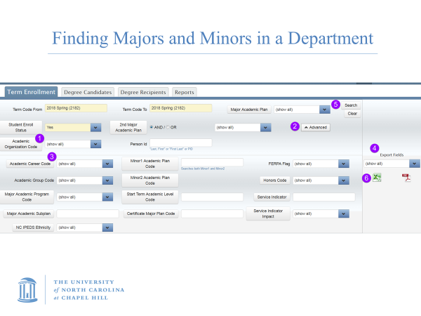
Figure 2
